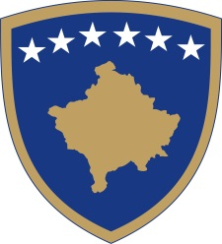
Republika e Kosovës
Republika Kosova - Republic of Kosovo
Qeveria - Vlada - Government

No. 01/181
Date: 04.01.2024

In support of Article 92 paragraph 4. and Article 93 paragraph 4 of the Constitution of the Republic of Kosovo, Article 8 of Law No. 08/L-117 for the Government of the Republic of Kosovo, in accordance with Article 5, 17 and 19 of the Rules of Procedure of the Government of the Republic of Kosovo No. 09/2011, the Government of the Republic of Kosovo, at the meeting held on January 4, 2024, receives this:

D E C I S I O N

- The Decision of the Government of the Republic of Kosovo No. 05/103 dated October 28, 2022 ("Decision") is amended and supplemented by Decision No. 01/170 dated October 30, 2023 and Decision No. 01/ 176 of November 30, 2023, as follows:

  - Point 7. of the Decision is annulled.
  - From point 8. of the Decision, the second sentence is deleted.

- The Ministry of Internal Affairs is obliged to implement this Decision.

- The decision enters into force on the day of publication in the Official Gazette of the Republic of Kosovo.

Albin KURTI

__________________________________
Prime Minister of the Republic of Kosovo

- Sent to:
• Deputy Prime Ministers
• All ministries (ministers)
• Secretary General of OPM
• Government Archive

