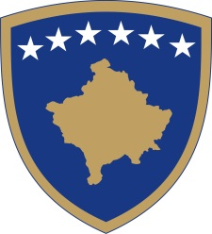
Republika e Kosovës
Republika Kosova - Republic of Kosovo
Qeveria - Vlada - Government

No. 01/13
Date: 18.03.2020

Pursuant to Article 92 paragraph 4 and Article 93 paragraph (4) of the Constitution of the Republic of Kosovo, Article 41 of Law no. 02 / L-109 on the Prevention and Fighting of Infectious Diseases, Article 2 of Law no. 04 / L-072 on control of the state border, based on section 4 of Regulation no. 05/2020 on Areas of Administrative Responsibility of the Office of the Prime Minister and Ministries, in accordance with Article 17 of the Rules of Procedure of the Government of the Republic of Kosovo No. 09/2011, The Government of the Republic of Kosovo at its meeting held on 18 March 2020 issues the following:

D E C I S I O N
For the designation of the Student Center in Pristina as a quarantine space

- Student Center in Pristina is designated as a Quarantine Area.

- Persons found to have been or are suspected of having been in direct contact with persons infected or suspected of being infected by the Corona Virus COVID-19 shall be quarantined.

- Student Center in Pristina, is under the direct management of the Ministry of Health, until the dismissing state of emergency announced by the Government of Kosovo with the Decision no. 01/11, dated March 15, 2020.

- The Ministry of Health, the Ministry of Education, Science, Technology and Innovation is obliged to carry out all procedures for the implementation of this decision.

- The decision shall enter into force immediately.

Albin KURTI

_________________________________
Prime Minister of the Republic of Kosovo

Sent to:

Deputy Prime Ministers
All ministries (ministers)
OPM Secretary General
Government Archive

