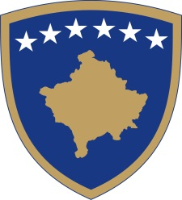
Republika e Kosovës
Republika Kosova - Republic of Kosovo
Qeveria - Vlada - Government

No. 01/11
Date: 15.03.2020

Pursuant to Article 92 paragraph 4 and Article 93 paragraph (4) of the Constitution of the Republic of Kosovo, Article 89 of Law no. 04/L-125 on Health, and pursuant to Article 41 of LAW no. 02/L-109 for Prevention and Fighting against Infectious Diseases, based on Article 4 of the Regulation (GRK) – no. 05/2020 on the Areas of Administrative Responsibility of the Office of the Prime Minister and Ministries, in accordance with Article 17 of the Rules of Procedure of the Government of the Republic of Kosovo no. 09/2011, the Government of the Republic of Kosovo, in its meeting held on 15 March 2020, issues the following:

DECISION
for declaration of the public health emergency

- The request of the Ministry of Health for the Government of the Republic of Kosovo to declare a public health emergency is approved.

- The institutions of the Government of the Republic of Kosovo are obliged to act in accordance with the National Response Plan and the activation of the emergency support function 8 (ESF8 public health and medical services).

- The Ministry of Health is responsible for managing the declared public health emergency situation.

- The decision shall enter into force immediately.

Albin KURTI

_________________________________
Prime Minister of the Republic of Kosovo

To be sent to:

- Deputy Prime Ministers
- All ministries (ministers)
- Secretary General of the OPM
- Government Archive

