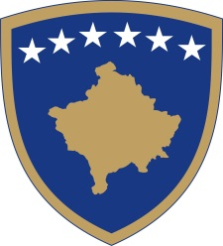
Republika e Kosovës
Republika Kosova - Republic of Kosovo
Qeveria - Vlada - Government

No. 01/10
Date: 14.03.2020

Pursuant to Article 92, paragraph 4 and Article 93 paragraph (4) of the Constitution of the Republic of Kosovo, Article 41 of the Law No. 02/L-109 for Prevention and Fighting against Infectious Diseases, Law no. 04/L-072 on State Border Control and Surveillance, and based on Article 4 of the Regulation No. 05/2020 on the Areas of Administrative Responsibilities of the Office of the Prime Minister and Ministries, and in compliance with Article 17 of the Regulation no. 09/2011 of the Rules and Procedures of the Government of the Republic of Kosovo, the Government of the Republic of Kosovo issues the following:

DECISION

On additional measures following confirmation of positive cases with Corona Virus Diseases COVID-19, as continuation of the Decision No. 01/09 dated 13th of March 2020

- The entry-exits of citizens in the municipality of Malisheva are banned.

- The Ministry of Internal Affairs and Public Administration, and the Ministry of Health and other relevant institutions are obliged to carry out all of the procedures for implementation of this decision.

- The Decision shall enter into force immediately

Albin KURTI

_________________________________
Prime Minister of the Republic of Kosovo

Sent to:

- Deputy Prime Ministers
- All ministries (ministers)
- Secretary General of the OPM
- Government archive

