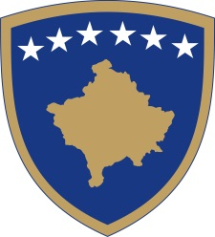
Republika e Kosovës
Republika Kosova - Republic of Kosovo
Qeveria - Vlada - Government

No. 01/30
Date: 24.08.2021

Pursuant to Article 92, paragraph 4, and Article 93, paragraph 4 of the Constitution of the Republic of Kosovo, Article 80 of Law No. 06/L-026 on Asylum, pursuant to Article 4 of Regulation no. 02/2021 on the Areas of Administrative Responsibility of the Office of the Prime Minister and Ministries, in accordance with Articles 17 and 19 of the Regulation No. 09/11 of Rules and Procedure of the Government of the Republic of Kosovo, the Government of the Republic of Kosovo, in the meeting held on 24 August 2021, issues the following:

DECISION

- Item 2 of the Decision No. 01/28 of the Government of the Republic of Kosovo dated 16.08.2021, as amended and supplemented by Decision No. 01/28, dated 21.08.2021 for provision of temporary and immediate protection to persons at risk of internal conflict in Afghanistan, as follows:

- Persons eligible for assistance under item 1 of this Decision are persons in the process of applying for US Special Immigrant Visa (SIV), as well as those qualified under group P2 (special classification determined by the US Department of State as Priority 2), and other persons identified, based on the agreement with USA, who will be relocated to the USA or another third country, including family members of these groups..

- This decision shall enter into force on the day of publication in the Official Gazette of the
- Republic of Kosovo.

Albin KURTI

__________________________________
Prime Minister of the Republic of Kosovo

Sent to:

- Deputy Prime Ministers
- All ministries (ministers)
- Secretary General of the OPM
- Government Archive

