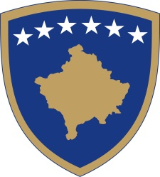
Republika e Kosovës
Republika Kosova - Republic of Kosovo
Qeveria - Vlada - Government

No. 01/16
Date: 26.03.2020

Pursuant to Article 92, paragraph 4, and Article 93, paragraph (4), of the Constitution of the Republic of Kosovo, based on Article 4 of Regulation No. 05/2020 on Areas of Administrative Responsibility of the Office of the Prime Minister and Ministries, in accordance with Articles 17 and 19 of the Rules of Procedure of the Government of the Republic of Kosovo No. 09/2011, the incumbent Government of the Republic of Kosovo, at its meeting held on 26 March 2020, issued the following:

D E C I S I O N

- The Government Decision No. 01/07 dated 11.03.2020 on the Prevention of Corona Virus COVID-19 is hereby amended and supplemented.

- The sub-paragraph 1.1. of paragraph 1. of the base decision shall be amended so that the termination of the educational process in Public and Private Educational Institutions at all levels shall continue until another decision, with the recommendation to release one of the parents from work (this measure does not apply to health workers and workers in the security sector).

- This decision is an integral part of Decision no. 01/07 dated 11.03.2020.

- The decision shall enter into force on the day of its signing.

Albin KURTI

_________________________________
Incumbent Prime Minister of the Republic of Kosovo

Sent to:

- Deputy Prime Ministers
- All Ministries (Ministers)
- Secretary General of OPM
- Government Archives

